Exchequer Enterprise

User-Defined Periods Hook

Set-up
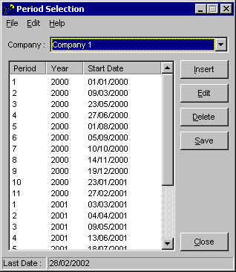
The User-Defined Periods Hook allows users to define financial periods based on specific dates. There are two components to the hook: a set-up program and the hook handler itself.

The main set-up screen is shown above. Each row represents a financial period and year, which starts at the date shown, and is deemed to run until the day preceding the start of the following period. The final period will terminate on the 'Last Date' shown in the status bar at the bottom of the screen. You can also select a company at the top of the screen - all settings are specific to the selected company.

Menu Options

File Menu

Save | Saves the current settings. You will be asked for confirmation.
Reload | Reloads the last saved settings. You will be asked for confirmation.
Export To File | Exports the settings to a text file (Periods.txt) in a simple format of:  Financial Period, Financial Year, Start Date, End Date  The default text file viewer (typically Windows Notepad) is run automatically.
Exit | Exits the set-up program.

Edit Menu

Insert | If a row is selected a new row will be inserted above it. If none is selected a new row is inserted at the end of the list. Enter the details in the dialog.  Keyboard shortcut = Insert key
Edit | Edits a selected row by displaying the edit dialog.  Mouse shortcut = Double click a row.  Keyboard shortcut = Enter key
Delete | Deletes the selected row.  Keyboard shortcut = Delete key
Last Date | Edits the 'Last Date' in the status bar.  Mouse shortcut = Double click the status bar
AutoFill | Displays the AutoFill dialog.
Undo AutoFill | Undoes the last AutoFill. If any editing has taken place since an AutoFill was run this option is unavailable.

Help Menu

About | Displays version information

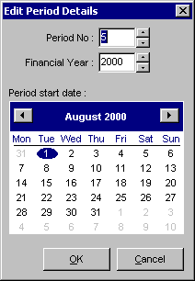
Editing a Period

Periods can be between 1 and 99.
Financial years can be between 1980 and 2100.
The selected start date is clearly highlighted. It is possible to move forward or backwards through the calendar using the left and right arrow buttons. Months and years can also be selected directly by clicking on the month or year within the calendar.
To accept the changes click OK, to ignore click Cancel.

Editing the Last Date

When editing the last date a screen almost identical to that shown above appears (the period and financial year fields are missing). Use in the same manner as editing a period.

Using AutoFill
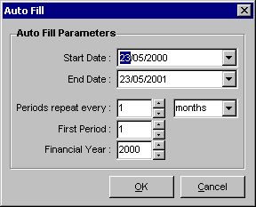

AutoFill is designed to allow the convenient addition of a number of periods to the set-up. The first period will start on the Start Date. End Date is nominally the last date that will be used. Periods can be set to repeat every n days, weeks, months or periods. A maximum of 99 periods will be generated, and all periods will belong to the financial year specified. If periods are selected the time period will be split into the number of periods selected with any 'overflow' days allocated to the final period. The set-up program will automatically adjust the Last Date if the AutoFill End Date is later than it is set to currently. It is worth remembering that it may be necessary to manually adjust the Last Date if a previous AutoFill operation has forced it to be later than is now required. If no editing has occurred subsequent to an AutoFill, it is possible to 'roll back' the operation using Undo AutoFill. Otherwise the most convenient method to remove rows generated with AutoFill is to select the first row and then delete line by line.

Validation
When the period settings are saved the program will attempt to validate the settings. The periods must run continuously i.e. 1, 2, 3 etc. without gaps and mustn't be duplicated within a financial year. The dates have to increment down the list.

Installation
The installation routine differs depending on which version of the User-Defined Periods Hook is to be used.

Installing the COM Client Version
- Copy the following supplied files into your Exchequer Enterprise v4.31 directory:
PrdSetup.exe The set-up program.
PHookCOM.exe The COM client
- In the Enterprise directory, edit EntCustm.Ini and add the following section:
[COMClients]
1="c:\Exch\Entrprse\PHookCOM.exe"
If this section already exists, add an additional line into this pre-existing section with the next available number.
- Run Enterprise and scroll down in the Help | About dialog, you should see the following text:
User-defined Period Hook – COM
Version 4.31.002/COM
Copyright (c) 2000 Exchequer Software Ltd

The presence of this text indicates the COM hook is working and you can proceed, if this text is not present then the hook is not active – review step 2.

Installing the Delphi DLL Version
- Copy the following supplied files into your Exchequer Enterprise v4.31 directory:
PrdSetup.exe The set-up program.
PerHook.dll The Delphi Hook DLL
- In the Enterprise directory, edit EntCustm.Ini and add the following section:-
[HookChain]
ENTCUSTM=PERHOOK
If an ‘ENTCUSTM=’ entry already exists then it is possible to extend the list e.g. If the INI file contains the following:
[HookChain]
ENTCUSTM=CARHOOK
It will become:
[HookChain]
ENTCUSTM=CARHOOK
CARHOOK=PERHOOK
- Run Enterprise and scroll down in the Help | About dialog, you should see the following text:
User-Defined Period Hook – DLL
Version 4.31.002/DLL
Copyright (c) 2000 Exchequer Software Ltd
The presence of this text indicates the DLL hook is working and you can proceed, if this text is not present then the hook is not active – review step 2.

Technical Notes
The program stores all of its settings in a Windows INI file: Periods.ini. The set-up program will automatically generate this if it does not exist. Both the set-up program and the hook, look for the INI file in the data directory of the selected company. It is not recommended that this file be edited directly, although the format employed is relatively simple: the set-up utility is designed to offer a degree of validation.

